3 B.Create a prototype with familiar and unfamiliar navigation
elements. Evaluate ease of use with different user groups using
wireflow

🎯 AIM
To design a prototype with both familiar and unfamiliar navigation elements and evaluate ease of use across different user groups using Wireflow.
🔹 STEP 1: PLAN YOUR PROTOTYPE
1. Define Navigation Elements
✔ Familiar Navigation:
- NEXT button
- Back button
- Linear flow (screen → screen)
✔ Unfamiliar Navigation:
- Swipe gestures
- Hidden navigation (no visible buttons)
- Tap image to navigate
- Long press for extra info
2. Sketch Layout (Based on Your UI)
Create flow like this:
Colosseum → Christ → Taj Mahal → Greece Walls
Each screen contains:
- Image
- Title
- Facts list
- NEXT button
🔹 STEP 2: SET UP WIREFLOW PROJECT
- Go to https://wireflow.co/
- Click New Project
- Name: “Wonders Navigation Wireflow”
- Choose Blank Project
🔹 STEP 3: DESIGN YOUR WIREFLOW SCREENS
🟦 Create 4 Screens (Cards)
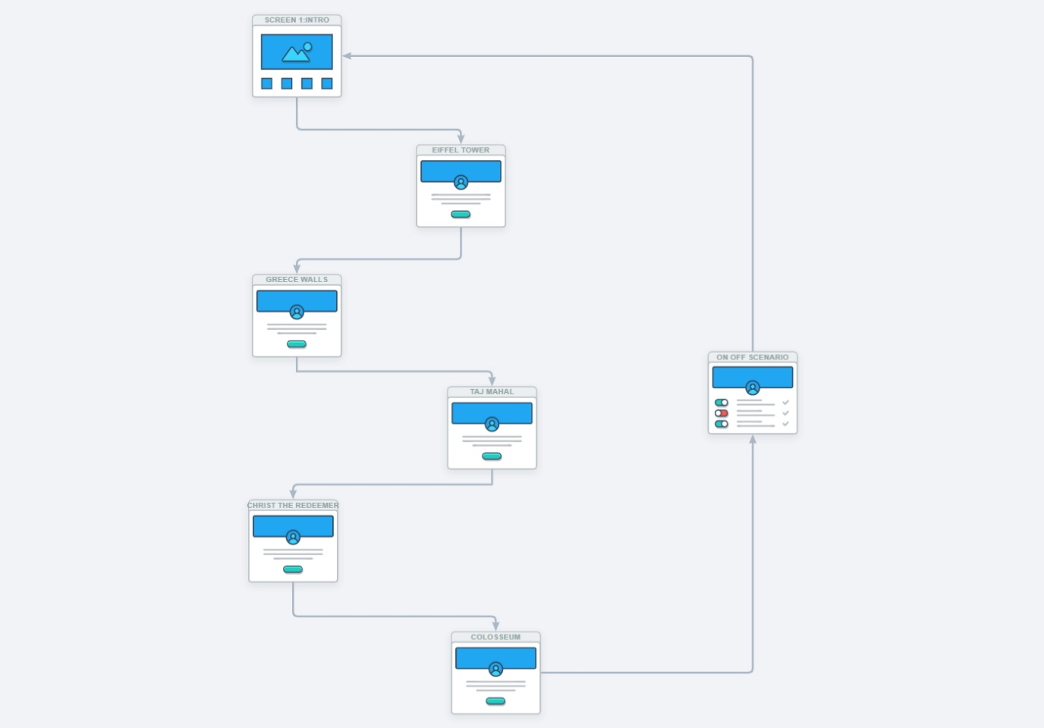
1. Colosseum Screen
- Label: Screen 1 – Colosseum
- Add:
  - Image placeholder
  - Text (facts)
  - Button: NEXT
2. Christ the Redeemer Screen
- Label: Screen 2 – Christ
- Same structure
3. Taj Mahal Screen
- Label: Screen 3 – Taj Mahal
4. Greece Walls Screen
- Label: Screen 4 – Greece Walls
🔹 STEP 4: ADD NAVIGATION FLOWS (IMPORTANT)
✔ Familiar Navigation Flow
Use arrows in Wireflow:
- Colosseum → Christ (NEXT button)
- Christ → Taj Mahal
- Taj Mahal → Greece Walls
Add Back arrows:
- Christ → Colosseum
- Taj Mahal → Christ
✔ Unfamiliar Navigation Flow
1. Swipe Navigation
- Add note on arrow:
  - “Swipe Left → Next Screen”
  - “Swipe Right → Previous Screen”
2. Hidden Navigation
- Add flow:
  - “Swipe Up → Jump to Greece Walls”
  - “Swipe Down → Go to Home”
3. Image Tap Navigation
- Add arrow:
  - “Tap Image → Next Screen”
4. Long Press Interaction
- Add note:
  - “Long press facts → Show popup”
🔹 STEP 5: LABEL YOUR FLOWS
👉 Very important for marks
Use annotations like:
- “Familiar Navigation”
- “Unfamiliar Navigation”
- “Gesture-based interaction”
🔹 FINAL CONCLUSION
- Familiar navigation improves usability
- Unfamiliar navigation adds innovation but reduces clarity
- Best UI combines both elements

